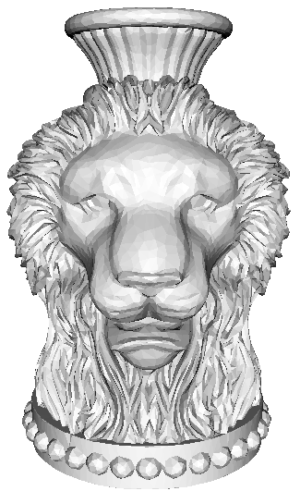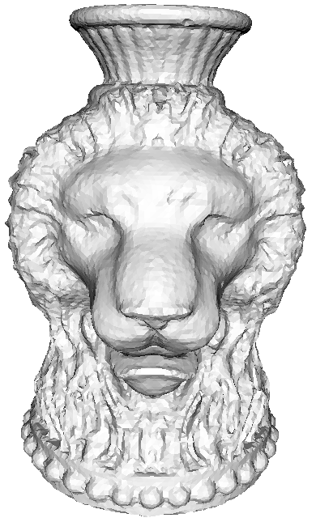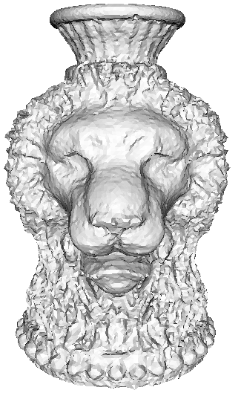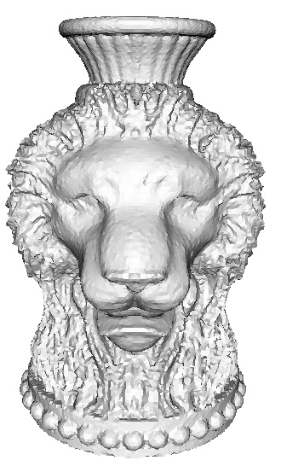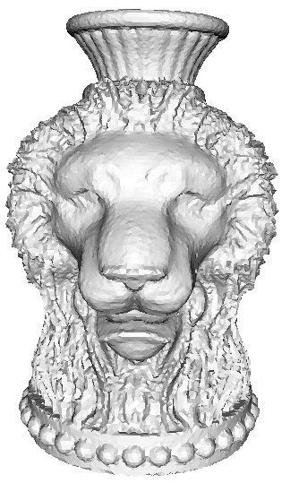
Oringal mesh Point to point_cloest Point to plane_cloest Point to point_normal_1 Point to point_normal_2
Conclusion:
We think the 2 iteration result (point to point energy, normal direction intersection method) is better, except the region of hair (maybe induced by low resolution) and the sharp bottom corner.

